Network Configuration

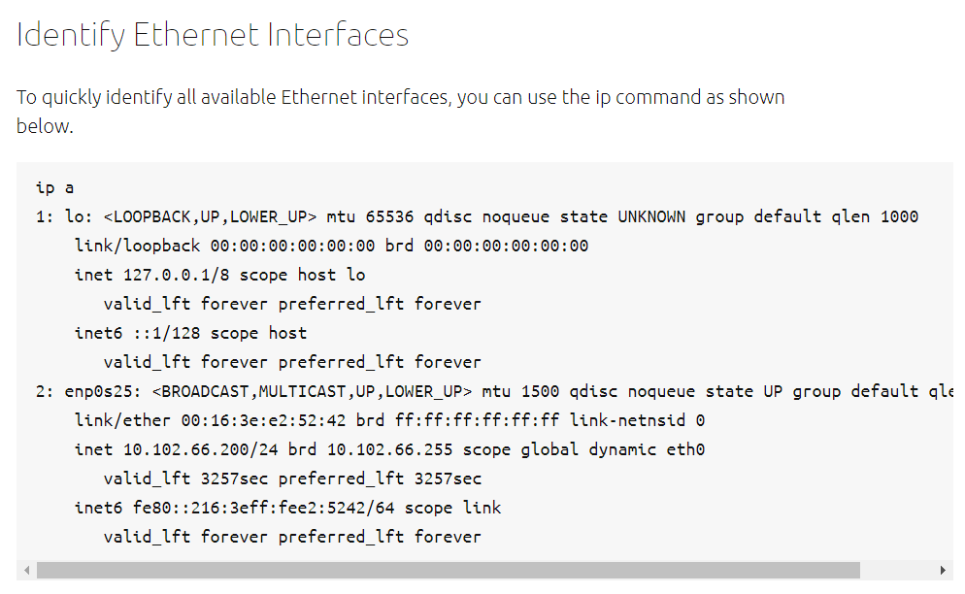Another application that can help identify all network interfaces available to your system is the lshw command. This command provides greater details around the hardware capabilities of specific adapters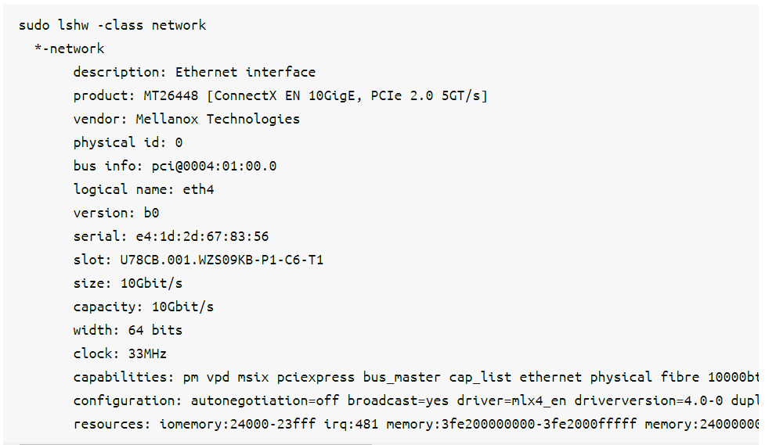

### **Ethernet Interface Logical Names**

Interface logical names can also be configured via a netplan configuration. If you would like control which interface receives a particular logical name use the match and set-name keys. The match key is used to find an adapter based on some criteria like MAC address, driver, etc. Then the set-name key can be used to change the device to the desired logial name.

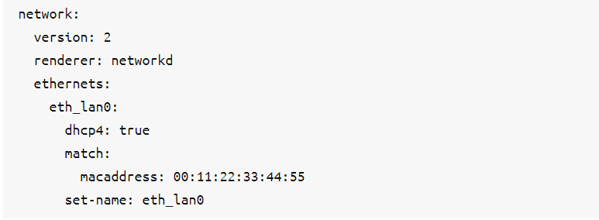

Ethernet Interface Settings

ethtool is a program that displays and changes Ethernet card settings such as auto-negotiation, port speed, duplex mode, and Wake-on-LAN. The following is an example of how to view supported features and configured settings of an Ethernet interface.

## **IP Addressing**

### **Temporary IP Address Assignment**

### **Dynamic IP Address Assignment (DHCP Client)**

